

Test plan MAG VIS EVK Modules
  - Subject: Test Plan: MAG VIS EVK Modules - Electrical and Functional Verification

Author: Seppe Servotte

version | Date | Reviewed | Approved by
1v0 | 2025-04-23

Revision history
Version | Date | Revisions
1v0 | 2025-04-23 | First version  Reviewed by:  Approved by:

Table of Contents
Revision history 2
Table of Contents 3
List of Figures 5
List of Tables 6
1 Document purpose and scope 7
2 Test strategy 8
2.1 Test conditions 8
2.2 Test stages 8
2.2.1 Visual inspection (VI) 9
2.2.2 Functional verification (VER) 9
2.3 Test flow 9
2.4 Test sequence 10
2.5 Test equipment 11
2.6 Statistical analysis 11
2.6.1 Bin groups 11
3 Measurement test setup 12
3.1 Test hardware 12
3.1.1 Overview 12
3.1.2 DUT information 14
3.1.3 Pin load requirements 14
3.1.4 Power supplies 15
3.2 Test software 15
3.2.1 Overview 15
3.2.2 Park state routine 15
3.2.3 Power cycle routines 15
4 Test procedures 17
4.1 T0001: Visual inspection (VI) 17
4.2 T0002: Power consumption 18
4.3 T0003: CXP Core functionality and video data check 19
4.4 T0004: IMG Core functionality and video data check 21
4.5 T0005: IMG Trigger mode 22
4.6 T0006: MAG-DRV Capabilities (only for MAG-VIS1000x modules) 24
4.7 T0007: MAG-DRV Motor drive capabilities (only for MAG-VIS1002x modules) 26
List of Acronyms 28
Appendix A MAG-CXP IC Iniatilze SPI and Clock code snippet 30
Appendix B MAG-DRV IC Reset and clear all 31

List of Figures
Figure 1: MAG VIS EVK Module production test flow diagram 10
Figure 2: Measurement setup overview 12
Figure 3: MAG-VIS1000X Measurement setup overview 13
Figure 4: MAG-VIS1002X Measurement setup overview 13

List of Tables
Table 1: Supply voltage conditions 8
Table 2: Imager modes 8
Table 3: Test stages 8
Table 4: Test sequence per test stage 10
Table 5: Measurement Equipment overview 11
Table 6: Bin table 11
Table 7: Pin list vs equipment matrix 14
Table 8: Power supplies 15
Table 9: Park state pin biasing 15
Table 10: Visual inspection overview 17
Table 11: Power consumption overview 18
Table 12: CXP Core functionality and video data check overview 19
Table 13: IMG Core functionality and video data check overview 21
Table 14: IMG Trigger mode overview 22
Table 15: MAG-DRV Capabilities overview 24
Table 16: MAG-DRV Motor drive capabilities overview 26

Document purpose and scope
This document is part of the MAG-VIS100xx-N Modules project and defines the test strategy, test setup and the detailed test procedures to perform electrical and functional verification. Radiation testing is out of scope of this test plan, these test are not done on individual MAG-VIS modules.

All the information in this document is intended to describe the verification tests that will be done on the products mentioned above. Any major deviations from this plan will be discussed prior or at latest during the test readiness review (TRR) meeting with the customer. Major changes will be listed in the revision history. Major changes can be (list is not exclusive):
- Number of DUT’s
- Test conditions
- Hardware/equipment changes
- Test facility changes
- Addition or removal of tests
- Any update to a test procedure that changes the test coverage or testing strategy

Minor changes are kept in the revision history but not explicitly informed to the customer. These changes are limited to:
- Small changes in a test procedure, e.g. additional SPI commands, increasing wait times
- Correction of typo’s
Any changes (major and minor) after the TRR meeting will be discussed with the customer.

Test strategy
This chapter describes the test methods used for the verification and validation of the MAG-VIS100xx-N modules. The test strategy aims at maximal test coverage of the product.
Functional testing and electrical parametric testing of the test structures is used to verify the performance.

Test conditions
During functional verification testing the temperature and supply voltage of the DUTs will be varied to validate the module specifications over the defined operating conditions. The conditions listed in this section are the minimal set of conditions that will be tested. If additional test conditions are needed to validate certain parameters, then they are explicitly mentioned in the test procedure.
Temperature conditions are mentioned in this document with following codes:
- RT = room temperature = 25°C +/- 5°C
- CT = cold temperature = 0°C +/- 5°C
- HT = hot temperature = 55°C +/- 5°C
Supply voltage conditions are defined in the table below:
Table 1: Supply voltage conditions
Supply level | Minimal | Nominal | Maximal | Comments
VDD_IN | 6V | 9V | 12V

The different imager modes are defined in the table below. The default imager mode is FHD10 unless otherwise specified.
Table 2: Imager modes
Imager mode | FPS | Image size height | Image size width
FHD10 | 10 | 1080 | 1920
FHD30 | 30 | 1080 | 1920
VGA50 | 50 | 480 | 640

Test stages
Table 3 outlines all the test stages required to validate the performance of the test vehicle, while section 2.3 details the sequence in which these test stages fit into the overall test flow.
Table 3: Test stages
Name | Code | Temperature | Supply | Other conditions | Number of parts | Comments
Production and screening tests
Visual inspection | VI | / | / | / | All
Final test | FT | RT, TBD | Vnom, TBD | / | All
Device verification tests
Functional verification | VER | CT, RT, HT | Vnom, Vmin, Vmax | / | All | Any test conditions (temperature, supply voltage, etc.) deviating from the defaults listed in this table will be explicitly defined within the respective test procedure.
The following sections provide further details on the different test stages.

Visual inspection (VI)
The purpose of the external visual inspection test stage is to assess the physical condition of the Device Under Test (DUT) before testing. This stage helps identify any visible defects, such as cracks, issues with pins, delamination, or other mechanical damages that may have occurred during handling, or transportation. By conducting a thorough visual examination, potential issues can be detected early, preventing further testing on compromised components and ensuring the reliability of the test results.

Functional verification (VER)
The functional verification stage is intended to confirm that the product is in compliance (functional and/or parametric) against its documentation for normal use-case(s).

Test flow
This section defines the test flow that every part will follow.
Approved devices are defined as PCBs that have undergone and successfully passed all required verifications outlined in their dedicated, product-specific test plan. PCBs achieving this status are formally designated as fit for inclusion within an EVK assembly.
The removal of the imager's glass protection is performed only when the module assembly includes a dedicated housing and mounted lens (see Figure 1, left flow). This step is omitted if the housing is not included (see Figure 1, right flow).
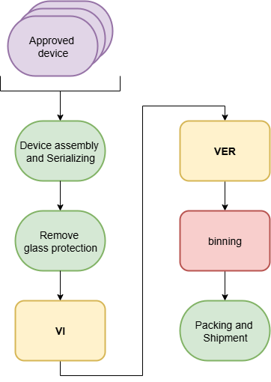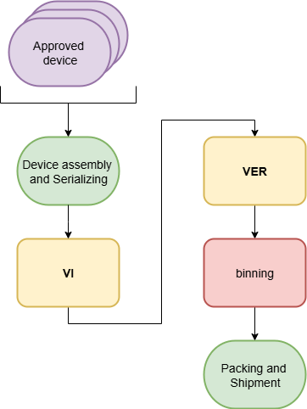
Figure 1: MAG VIS EVK Module production test flow diagram

Test sequence
Table 4 provides an overview of the various tests conducted at each test stage and outlines the correct test sequence, which should be followed from top to bottom.
Table 4: Test sequence per test stage
Test | VI | VER | Comments
T0001: Visual inspection (VI) | X |  | Always the first test.
T0002: Power consumption |  | X | Measures current under various conditions.
T0003: CXP Core functionality and video data check |  | X | Verifies CoaXPress communication and data integrity.
T0004: IMG Core functionality and video data check |  | X | Verifies Imager functionality and internal pattern generator.
T0005: IMG Trigger mode |  | X | Verifies the imager's ability to operate under external command.
T0006: MAG-DRV Capabilities (only for MAG-VIS1000x modules) |  | X | Conditional: Applicable only to MAG-VIS1000x modules.
T0007: MAG-DRV Motor drive capabilities (only for MAG-VIS1002x modules) |  | X | Conditional: Applicable only to MAG-VIS1002x modules.

Test equipment
All test equipment is listed in Table 5. This table provide recommendations for the required instruments during the different test, indicate their availability based on the test schedule, and specify whether the equipment remains calibrated throughout the various test phases.
Table 5: Measurement Equipment overview
Instrument name | Instrument type | Short description | Available | Calibrated
PC | Rack PC | Test computer | TBC | NA
Frame Grabber | Matrox Rapixo CXP Frame Grabber | / | TBC | NA
PSU | NGL202 | 2 channel power supply | TBC | Yes
DMMV | Keysight 34465A | 6.5-digit basic Truevolt DMM | TBC | Yes
THERMO STREAMER | Temptronic ECO-710E-M | / | TBC | Yes
SCOPE | Keysight DSOX1204G | 4 Analog Channels Oscilloscope | TBC | Yes

Statistical analysis

Bin groups
Following table gives an overview of the bin groups. Bin 1 is always the PASS bin. Bin groups between 2 and 99 are reserved for PASS with limited performance. Groups starting from 200 are FAILS and should be scrapped.
Table 6: Bin table
Bin group | Resolution
1 | PASS
200 | FAIL

Measurement test setup
This chapter explains how to collect measurement data from individual DUTs while working with a limited amount of lab equipment. It also details the instruments used in the test setup, along with all hardware-related requirements. Additionally, the section covers the software used to control the test setup, including software-specific details.

Test hardware

Overview
Figure 2 provides an overview of the complete test setup used for most tests outlined in the test procedures (Chapter 4). As shown in the diagram, the Devices Under Test (DUTs) are placed within a temperature-controlled environment, which may be maintained using a thermostreamer or temperature chamber to ensure stable and controlled test conditions.
To enable automated test execution, all instruments are connected through Ethernet and centrally controlled by a test PC. This setup ensures efficient data acquisition, measurement synchronization, and automated execution of the defined test procedures.

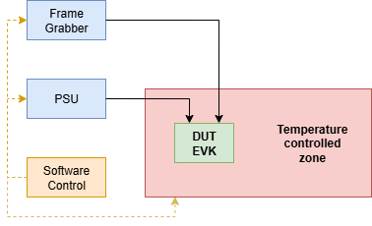
Figure 2: Measurement setup overview
The MAG-VIS100xx modules require an adapted measurement configuration to facilitate the functionality of the MAG-DRV IC. The adapted setup incorporates the following additional equipment:
- Oscilloscope: Required for waveform capture and timing analysis. This verifies the operation of the MAG-DRV IC, including successful generation of ON/OFF output signals and the generation of PWM signals.
- Magics MUX Card: A multiplexer card is integrated to multiplex the outputs of the MAG-DRV IC to the oscilloscope.
- Power resistors: These resistors are added to limit the current flow trough the drivers of MAG-DRV IC.
The measurement setup overview diagram for the MAG-VIS1000x will be constrained to highlight only the new, module-specific test equipment. The core system components (Frame Grabber, PSU, and Control Software) are mandatory elements of the EVK test platform and will be intentionally omitted from the specific diagram to maintain clarity and avoid unnecessary clutter.
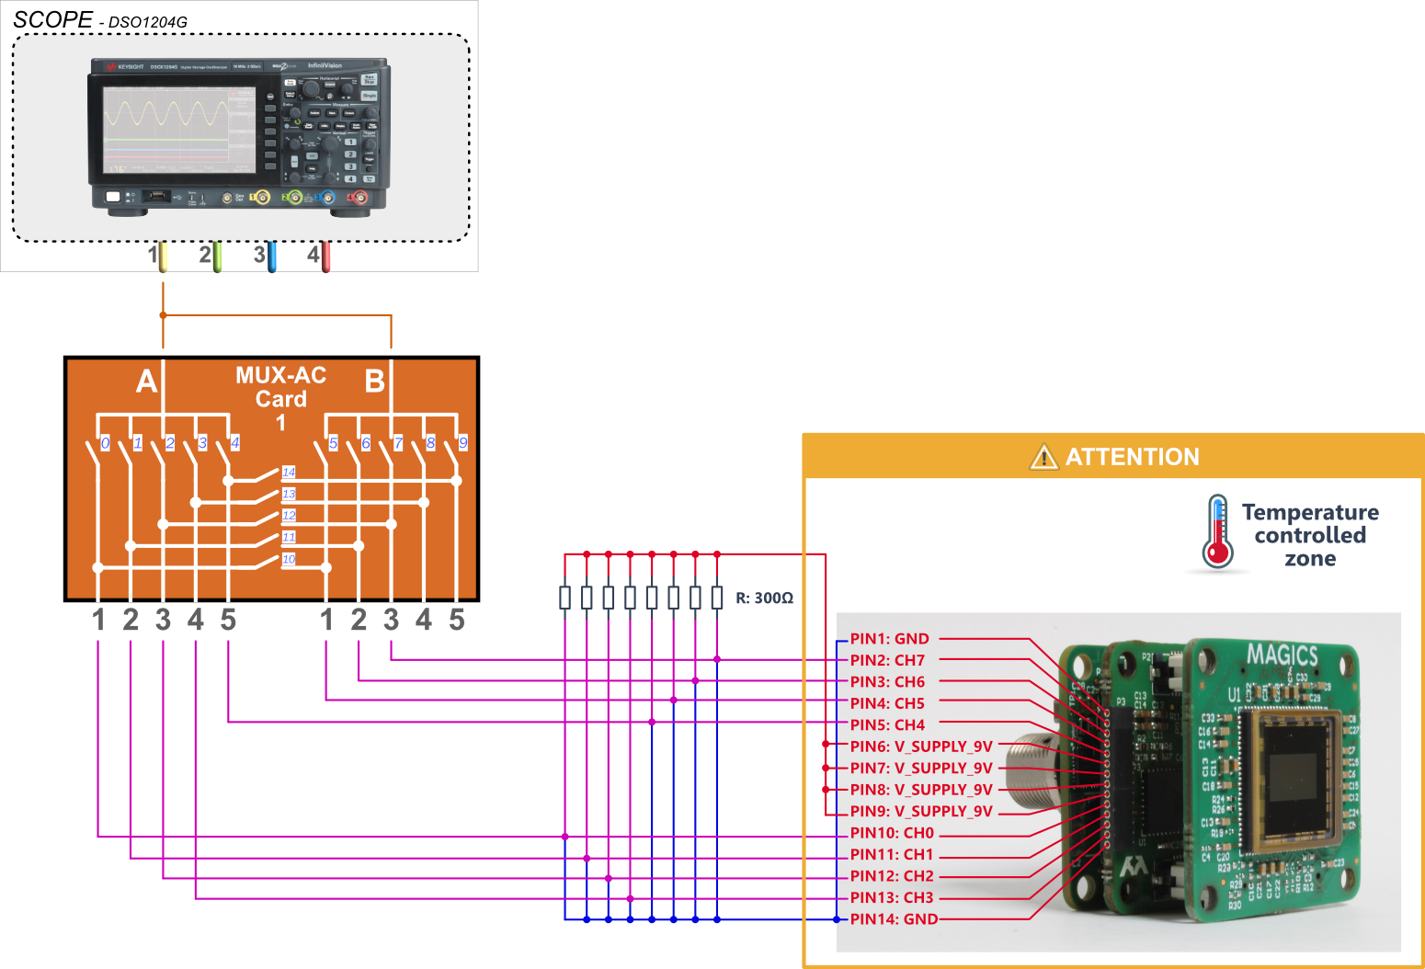
Figure 3: MAG-VIS1000X Measurement setup overview

The MAG-VIS1002x modules require an adapted measurement configuration to facilitate the functionality of the MAG-DRV IC to drive motors of a lens. The core system components (Frame Grabber, PSU, and Control Software) are mandatory elements of the EVK test platform and will be intentionally omitted from the specific diagram to maintain clarity and avoid unnecessary clutter.
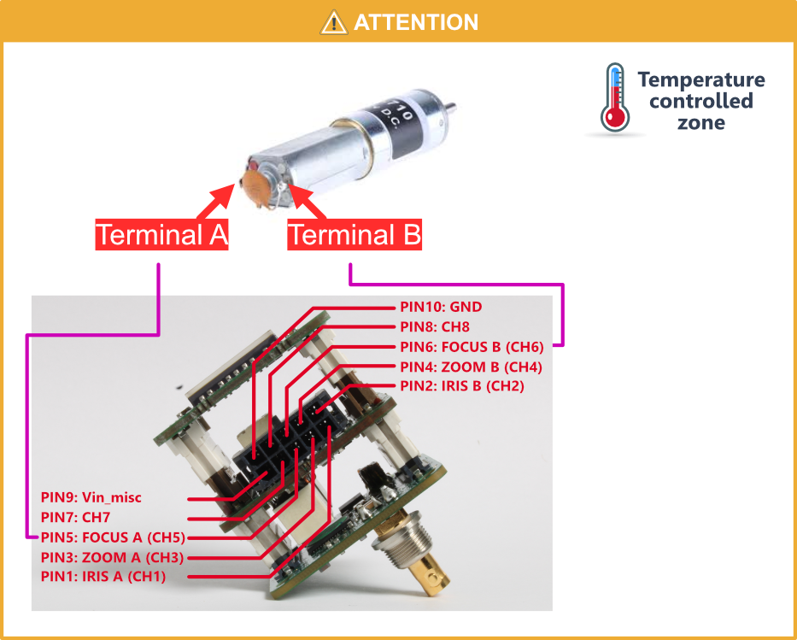
Figure 4: MAG-VIS1002X Measurement setup overview

DUT information
To limit the use of equipment channels, the DUTs are measured using a time-multiplexed approach, ensuring that only one device is tested at a time (single-site test setup).
Table 7 provides a detailed overview of all DUT pins and specifies the corresponding test equipment required for each pin to execute the defined test procedures.
For debugging purposes, additional connections to the test equipment may be beneficial. These optional connections are marked with the postfix "∗" in the table. The following codes are used in the matrix:
- HI_F: Forced voltage or current at the pin
- HI_S, LO_S: Sensed voltage or current at the pin
- LO_F: Return path
- HI_IN: Sensed voltage or current at the pin connects to HI input of DMM or scope
- LO_IN: Sensed voltage or current at the pin connects to LO input of DMM
- CHx: Input of oscilloscope with x in range [1 to 4]

Table 7: Pin list vs equipment matrix
Equip  Pin | SCOPE | Frame grabber | PSU (2-wire)
TRXN |  | HI_F
TRXP |  | HI_S
VDD_IN |  |  | HI_F
GND | LO_F *(1) |  | LO_F
CH0
CH1 *(1) | CH1
CH2 *(1) | CH1
CH3 *(1) | CH1
CH4 *(1) | CH1
CH5 *(1) | CH1
CH6 *(1) | CH1
CH7 *(1) | CH1
*(1) Only applicable for the MAG-VIS1000X modules.

Pin load requirements
During the hardware development attention needs to be given to following items:
- Low-ohmic connections
  - For ground and power connections.
- Impedance matched signals
  - TRXP/TRXN: The TRXN pin is connected to a Coax transmission line leading to the frame grabber, while the TRXP pin is terminated on the substrate board. Matching must adhere to the 75Ω transmission line standard.

Power supplies
Power is supplied to the DUT using bench Power Supply Units (PSUs). All DUT supply channels are listed in Table 8, where the "default connected" column indicates whether a channel is connected by default during testing unless otherwise specified in the test procedure. The supply can either be directly connected to the pin, via a relays or via an DMMI for most accurate supply current measurements. The PSU channels can be split over different bench equipment depending on availability and sourcing/measurement requirements.
The power-up and power-down sequence for default-connected supplies is detailed in Section 3.2.3. To prevent voltage overshoot, it is strongly recommended to use power sources with a controllable soft ramp.
Table 8: Power supplies
DUT pin name | Supply domain (Table 1) | Default connected | PSU channel | Alias | Comments
VDD_IN | VDD_IN | Yes | 1

Test software

Overview
The software test suite is an in-house build environment using Python scripts (i.e. Experimate) to control following:
- settings for MaTeR and measurement equipment,
- connectivity between the DUTs and the equipment,
- supply and temperature control,
- FPGA for e.g. serial interfacing with the DUT,
- logging of measurement data and meta data to a database and
- settings for the load board.

Park state routine
Before each test procedure starts the DUT and the test setup is brought to a known default state (park state). This includes driving following IO pins to:
Table 9: Park state pin biasing
Pin name | Biased to level / dynamic signal (f, dc, swing) | Comment
VDD_IN | Supply 9V
GND | Ground
TRXN | Frame Grabber | The DC state is don’t care since there are DC blocking caps in the pad towards the input of module

Power cycle routines
Power-up sequence:
- Disconnect all measurement equipment
- Apply PSU-9V = VDD_IN = 0V
- Wait 10ms
- Ramp up VDD_IN to its defined operating condition 9V in 10ms or slower
Power-down sequence:
- Ramp down VDD_IN to 0V in 10ms or slower
- Disconnect all measurement equipment

Test procedures
This chapter contains an overview of all the tests included in the test sequence(s). In the overview items as high-level description, test configuration, test conditions, detailed test procedure and acceptance criteria are discussed.

T0001: Visual inspection (VI)
Table 10: Visual inspection overview
Test Description
To verify the physical integrity of the DUT prior to electrical testing, ensuring no mechanical damage, solder defects or contamination is present that could affect performance or safety.
Test Configuration
An ESD-safe work place. No software is required.
Test Equipment Requirements
- Magnification device
- High-contrast lighting for performing inspection
Test Conditions
None. This test is performed at Room Temperature (RT) and V_{min}/V_{nom}/V_{max} are not applicable.
Environmental conditions
Manual inspection performed on an ESD-safe workstation in a clean, ambient environment.
Test Procedure
Step | Action |  |  | Register parameter |  | Value
 | Ensure DUT is not connected to any power source.
 | Inspect PCB surfaces for scratches, delamination, or burn marks.
 | Inspect all components for cracks, correct orientation and clear marking.
 | Inspect all solder joints for opens, shorts, bridging, or insufficient wetting (dewetting).
 | Inspect all connectors and pins for bending, damage or contamination.
 | Inspect imager lens (if installed) and optical window for scratches, dust, or smudges.
 | Log PASS if no defects are found. Log the specific defect if FAIL.
Notes
No electrical measurements or power application is allowed during this test.
Test parameters and acceptance criteria
ID | Name | Unit | LTL |  | Typ |  | UTL
M0001 | VI_Pass
M0002 | VI_Defect_Code

T0002: Power consumption
Table 11: Power consumption overview
Test Description
This test measures the current consumption of the DUT.
Test Equipment Requirements
Hardware:
- PSU for forcing VDD_IN and measuring current consumption:
  - Current consumption accuracy: 100nA, range 100μA
  - Voltage source accuracy: 10mV, range 100mV
- Frame grabber to initiate the streaming mode
- Thermostreamer for CT/RT/HT testing

Test Conditions
Test is conducted at all power supply levels (see Table 1) and on CT, RT and HT.
Test Procedure
Step | Action |  |  | Register parameter |  | Value
 | Start from park state.
 | Configure the PSU to the appointed voltage.
 | Set up the imager to work in the appointed mode (Table 2).
 | Enable continuous acquisition mode |  |  | AcquisitionCommand_Value |  | 8
 | Wait 5s.
 | Measure the current consumption using the PSU, take an average of 10 measurements.
 | Log the current measurement.
Notes
P_VDD_IN_XXXX is calculated from the applied VDD_IN voltage and the measured current.
Test parameters and acceptance criteria
ID | Name | Unit | LTL |  | Typ |  | UTL
M0003 | I_ VDD_IN_FHD10 | mA
M0004 | P_ VDD_IN_FHD10 | W
M0005 | I_ VDD_IN_FHD30 | mA
M0006 | P_ VDD_IN_FHD30 | W
M0007 | I_ VDD_IN_VGA50 | mA
M0008 | P_ VDD_IN_VGA50 | W

T0003: CXP Core functionality and video data check
Table 12: CXP Core functionality and video data check overview
Test Description
This test verifies the basic functionality of the MAG-CXP00002-NP IC and the CoaXPress video data. It involves checking the lock bits, writing and reading a known register value via CoaXPress to confirm basic communication, enabling internal test pattern mode and verifying the correct pattern is received by the frame grabber.
Test Equipment Requirements
Hardware:
- PSU for forcing VDD_IN:
  - Voltage source accuracy: 10mV, range 100mV
- Frame grabber to initiate the streaming mode
- Thermostreamer for RT testing
Test Conditions
Test is conducted only at nominal voltage and room temperature (RT).
Test Procedure
Step | Action |  | Register parameter |  |  | Value
 | Start from park state.
 | Configure the PSU to the V_{nom.} voltage.
 | Set up the imager to work in FHD10 mode (Table 2).
 | Enable continuous acquisition mode |  | AcquisitionCommand_Value |  |  | 8
 | Wait 5s.
 | Read register |  | (PROX) Analog_constant_test
 | Check if read value matches and log pass/fail. |  | (PROX) Analog_constant_test |  |  | 0xAA
 | Write register |  | (PROX) VendorUniqueSPIGPIO_data_mosi |  |  | 0xCAFE123
 | Read register |  | (PROX) VendorUniqueSPIGPIO_data_mosi
 | Check if read value matches and log pass/fail. |  |  |  |  | 0xCAFE123
 | Read lock bits register |  | (PROX)  Analog_ct_lock_bits
 | Check if value matches and log value. |  |  |  |  | 2
 | Enable color mode of the Test pattern generator (TPG) to be able to capture color pattern. |  | (PROX) Analog_col_mono_tpg |  |  | 1
 | Set pixel size |  | (PROX)  PixelSize_Value |  |  | 10
 | Start of video mode loop.
 | Configure the first (next) video mode. |  | See Video mode table
 | Start of test pattern loop.
 | Configure the first (next) test pattern. |  | See Test pattern table
 | Start of frame rate loop.
 | Configure the first (next) frame rate. |  | (PROX)  AcquisitionFrameRate_Value |  |  | [10,30]
 | Enable stream
 | Capture image
 | Save image
Notes
Video mode table
Video mode | Register parameter | Value
VGA | ImageSize_Width | 640
 | ImageSize_Height | 480
HD | ImageSize_Width | 1280
 | ImageSize_Height | 720
FHD | ImageSize_Width | 1920
 | ImageSize_Height | 1080
Test Pattern table
Pattern | Register parameter | value
Black | TestPattern_Value | 1
White | TestPattern_Value | 2
Grey55 | TestPattern_Value | 3
GreyAA | TestPattern_Value | 4
GrayHorizontalRamp | TestPattern_Value | 16
GrayVerticalRamp | TestPattern_Value | 17
ColorBar | TestPattern_Value | 48
GreyScaleChart | TestPattern_Value | 49
VendorSpecific0 | TestPattern_Value | 120
VendorSpecific1 | TestPattern_Value | 121
VendorSpecific2 | TestPattern_Value | 122
VendorSpecific3 | TestPattern_Value | 123
VendorSpecific4 | TestPattern_Value | 124
VendorSpecific5 | TestPattern_Value | 125

- Test pattern validation: Every captured test pattern image is pixelwise compared to an already saved image of the test pattern.

Test parameters and acceptance criteria
ID | Name | Unit |  | LTL | Typ |  | UTL
M0009 | Constant register read transaction | Pass/Fail
M0010 | Register write/read transaction | Pass/Fail
M0011 | Read out lock bits
M0012 | Test pattern matching | % |  | 100 | 100 |  | 100

T0004: IMG Core functionality and video data check
Table 13: IMG Core functionality and video data check overview
Test Description
This test verifies the basic functionality of the MAG-IMG00XXX IC. It involves checking the PLL status bits, testing image manipulation logic (y-axis flip), enabling the internal Test Pattern Generator (TPG), and verifying the received image pattern via CoaXPress under various video modes and frame rates.
Test Equipment Requirements
Hardware:
- PSU for forcing VDD_IN:
  - Voltage source accuracy: 10mV, range 100mV
- Frame grabber to initiate the streaming mode
- Thermostreamer for RT testing
Test Conditions
Test is conducted only at nominal voltage and room temperature (RT).
Test Procedure
Step | Action |  | Register parameter |  |  | Value
 | Start from park state.
 | Configure the PSU to the V_{nom.} voltage.
 | Set up the imager to work in FHD10 mode (Table 2).
 | Enable continuous acquisition mode |  | AcquisitionCommand_Value |  |  | 8
 | Wait 5s.
 | Read lock bits register |  | (IMG)  AnalogTrimmimg_Pll_lock_detect_locked |  |  | 1
 | Check if value matches and log value.
 | Start of video mode loop.
 | Configure the first (next) video mode. |  | See Table 2
 | Start of test pattern loop.
 | Configure the first (next) test pattern. |  | See Test pattern table
 | Enable stream
 | Capture image
 | Save image
 | Set up the imager to work in FHD10 mode (Table 2).
 | Enable continuous acquisition mode |  | AcquisitionCommand_Value |  |  | 8
 | Enable TPG |  | (IMG)  TestPattern_Value |  |  | ??
 | Capture and save image (Image_A)
 | Enable y-axis mirror |  | (IMG)  ReverseY_Value |  |  | 1
 | Capture and save image (Image_B)
Notes
Test Pattern table
Pattern | Register parameter | value
Black | TestPattern_Value | 1
White | TestPattern_Value | 2
Grey55 | TestPattern_Value | 3
GreyAA | TestPattern_Value | 4
GrayHorizontalRamp | TestPattern_Value | 16
GrayVerticalRamp | TestPattern_Value | 17
ColorBar | TestPattern_Value | 48
GreyScaleChart | TestPattern_Value | 49
VendorSpecific0 | TestPattern_Value | 120
VendorSpecific1 | TestPattern_Value | 121
VendorSpecific2 | TestPattern_Value | 122
VendorSpecific3 | TestPattern_Value | 123
VendorSpecific4 | TestPattern_Value | 124
VendorSpecific5 | TestPattern_Value | 125

- Test pattern validation: Every captured test pattern image is pixelwise compared to an already saved image of the test pattern.
- Y-Axis Mirror validation: The success of the Y-axis image mirror function must be verified by pixel-wise comparison between a reference image (Image_A) captured before the mirror command and a test image (Image_B) captured after the mirror command is enabled.
  - Verification method: The validation software must confirm that Image_B is an exact mirror image of Image_A along the Y-axis (vertical center). Any deviation indicates a failure in the image manipulation logic.

Test parameters and acceptance criteria
ID | Name | Unit |  | LTL | Typ |  | UTL
M0013 | Read out lock bits
M0014 | Test pattern matching | % |  | 100 | 100 |  | 100
M0015 | Mirror y-axis | % |  | 100 | 100 |  | 100

T0005: IMG Trigger mode
Table 14: IMG Trigger mode overview
Test Description
This test provides full functional verification of all imager (IMG) trigger modes. It consists of three main parts:
- CXP-Hardware Trigger Flow: Confirms a trigger command sent via the CXP communication successfully toggles the hardware trigger pin on the MAG-CXP00002-NP IC, initiating a single-frame capture on the MAG-IMG00XXX imager IC.
- Imager Free-Run Burst Mode: Verifies the imager's ability to capture a programmed burst sequence of frames (30 frames) in MULTIFRAME mode without an external trigger.
- Imager Software Trigger Burst Mode: Confirms the imager's ability to capture a burst sequence (30 frames) when initiated by a direct software trigger command sent via SPI.
The Test Pattern Generator (TPG) is used throughout to verify data integrity.

Test Equipment Requirements
Hardware:
- PSU for forcing VDD_IN:
  - Voltage source accuracy: 10mV, range 100mV
- Frame grabber to initiate the streaming mode
- Thermostreamer for RT testing
Test Conditions
Test is conducted only at nominal voltage and room temperature (RT).
Test Procedure
Step | Action |  | Register parameter |  |  | Value
 | Start from park state.
 | Configure the PSU to the V_{nom.} voltage.
 | Set up the imager to work in FHD10 mode (Table 2).
 | Set acquisition command to MULTIFRAME mode. |  | (IMG)  AcquisitionCommand_Value |  |  | 9
 | Configure the CXP trigger source to software control. |  | (PROX)  TriggerSource_Value |  |  | 64
 | Configure the IMG trigger source to hardware control. |  | (IMG)  TriggerSource_Value |  |  | 120
 | Enable TPG |  | (IMG)  TestPattern_Value |  |  | ??
 | Set acquisition frame count to single frame capture. |  | (IMG)  TriggerAdditionalParameter_Value |  |  | 1
 | Set mode to hold until external (in this case a hardware) trigger is given. |  | (IMG)  TriggerMode_Value |  |  | 1
 | Enable a hardware toggle on the CXP IC by writing a register. |  | (CXP)  SoftwareTrigger_Value |  |  | 1
 | Capture and save the single frame.
 | Disable the hardware toggle on the CXP IC by writing a register. |  | (CXP)  SoftwareTrigger_Value |  |  | 0
 | Set acquisition command to STOP mode. |  | (IMG)  AcquisitionCommand_Value |  |  | 1
 | Set acquisition frame count to a burst of 30 frames. |  | (IMG)  AcquisitionFrameCount_Value |  |  | 30
 | Set mode to hold until software trigger is given. |  | (IMG)  TriggerMode_Value |  |  | 0
 | Set acquisition command to MULTIFRAME mode. To start the multi frame capturing. |  | (IMG)  AcquisitionCommand_Value |  |  | 9
 | Capture and save the burst of frames.
 | Read acquisition command, this should be automatically set back to 1. |  | (IMG)  AcquisitionCommand_Value |  |  | 1
 | Set acquisition frame count to a burst of 30 frames. |  | (IMG)  TriggerAdditionalParameter_Value |  |  | 30
 | Configure the IMG trigger source to software control. |  | (IMG)  TriggerSource_Value |  |  | 64
 | Set mode to hold until external (in this case a software) trigger is given. |  | (IMG)  TriggerMode_Value |  |  | 1
 | Set acquisition command to MULTIFRAME mode. |  | (IMG)  AcquisitionCommand_Value |  |  | 9
 | Give a software trigger directly to the IMG IC. |  | (IMG)  TriggerSource_Value |  |  | 1
 | Capture and save the burst of frames.
Notes
- Data integrity validation is mandatory for all captured frames. Each captured frame (single and burst) must be compared pixel-wise to a known, pre-saved reference frame corresponding to the configured pattern. This comparison must confirm a 100% match.

Test parameters and acceptance criteria
ID | Name | Unit |  | LTL | Typ | UTL
M0016 | HwTrig_SingleFrame_Count | Count |  | 1 | 1 | 1
M0017 | HwTrig_SingleFrame_TPG_Match | % |  | 100 | 100 | 100
M0018 | FreeRun_BurstFrame_Count | Count |  | 30 | 30 | 30
M0019 | FreeRun_BurstFrame_TPG_Match | % |  | 100 | 100 | 100
M0020 | SwTrig_BurstFrame_Count | Count |  | 30 | 30 | 30
M0021 | SwTrig_BurstFrame_TPG_Match | % |  | 100 | 100 | 100

T0006: MAG-DRV Capabilities (only for MAG-VIS1000x modules)
Table 15: MAG-DRV Capabilities overview
Test Description
This test provides functional verification of the MAG-DRV IC outputs in both steady-state (ON/OFF) and dynamic (PWM) modes. The test confirms that the driver successfully switches the output as commanded, using the oscilloscope and MAGICS MUX Card to quickly check all channels.

Test Equipment Requirements
Hardware:
- PSU for forcing VDD_IN:
  - Voltage source accuracy: 10mV, range 100mV
- Frame grabber to initiate the streaming mode
- Thermostreamer for RT testing

The test setup need to be adjusted as depicted in Figure 3.

Test Conditions
Test is conducted only at nominal voltage and room temperature (RT).
Test Procedure
Step | Action |  | Register parameter |  |  | Value
 | Start from park state.
 | Configure the PSU to the V_{nom.} voltage.
 | Set up the imager to work in FHD10 mode (Table 2).
 | Initialize SPI and output clock on the MAG-CXP IC. |  | See initializing code snippet  (Appendix A)
 | Reset and clear flags MAG-DRV IC . |  | See code snippet  (Appendix B)
 | Start channel steady-state testing loop.
 | Mux the first (next) channel to the oscilloscope.
 | Verify and log with scope if channel is in OFF state.
 | Drive channel to ON state. |  | (DRV)  drv_enable (0x0A) |  |  | Write 1 at Xth bit *(1)
 | Verify and log with scope if channel is in ON state.
 | Drive channel to OFF state. |  | (DRV)  drv_enable (0x0A) |  |  | Write 0 at Xth bit *(1)
 | Verify and log with scope if channel is in OFF state.
 | End channel steady-state testing loop.
 | Reset and clear flags MAG-DRV IC . |  | See code snippet  (Appendix B)
 | Disable PWM on all channels.. |  | (DRV)  PWM_en_X field (0x0C) |  |  | 0
 | Set PWM frequency. |  | (DRV)  PWM_freq (0x0D Bits 5:0) |  |  | 0
 | Set PWM low frequency . |  | (DRV)  PWM_low_freq (0x0D Bit 6) |  |  | 0
 | Set PWM reduce precision. |  | (DRV)  PWM_reduce_precision (0x0D Bit 7) |  |  | 1
 | Start channel PWM testing loop.
 | Set duty cycle to 50% for the corresponding channel. |  | See duty cycle note *(2) |  |  | 512 (decimal)
 | Enable PWM for the corresponding channel. |  | (DRV)  PWM_en_X (0x0C) |  |  | Write 1 at Xth bit
 | Drive channel. |  | (DRV)  drv_enable (0x0A) |  |  | Write 1 at Xth bit
 | Verify and log with scope if channel is in PWM drive mode.
 | Disable channel. |  | (DRV)  drv_enable (0x0A) |  |  | Write 0 at Xth bit
Notes
- *(1): Each channel in MAG-DRV00002-NP can be independently controlled via the 8 bits in the drv_enable field in register(0x0A). The Xth bit in this register represents the demanded state of the Xth channel of MAG-DRV00002-NP. When this bit is written to 1, the channel will be activated, the switch device will go in a conductive state until the bit is re-written to 0.
- *(2): The duty cycle of the channels can be individually programmed from 0% to 100% via the 10-bit field PWM_dcycle_x in registers (0x0F), (0x11), (0x13), (0x15), (0x17), (0x19), (0x1B) and (0x1D) that corresponds to each individual channel.

Test parameters and acceptance criteria
ID | Name | Unit |  | LTL | Typ | UTL
M0022 | OFF state verification | Pass/Fail
M0023 | ON state verification | Pass/Fail
M0024 | PWM frequency check | Hz |  |  | 40KHz
M0025 | PWM duty cycle | % |  |  | 50

T0007: MAG-DRV Motor drive capabilities (only for MAG-VIS1002x modules)
Table 16: MAG-DRV Motor drive capabilities overview
Test Description
This test provides functional verification of the MAG-DRV IC ability to drive external loads, specifically to control the directional movement of the Iris, Zoom, and Focus motors. The test iterates through each motor, verifies the correct drv_enable register values for both left and right direction achieve the intended physical motor movement, and ensures the motor can be safely disabled (OFF state).

Test Equipment Requirements
Hardware:
- PSU for forcing VDD_IN:
  - Voltage source accuracy: 10mV, range 100mV
- Frame grabber to initiate the streaming mode
- Thermostreamer for RT testing

The test setup need to be adjusted as depicted in Figure 4.

Test Conditions
Test is conducted only at nominal voltage and room temperature (RT).
Test Procedure
Step | Action |  | Register parameter |  |  | Value
 | Start from park state.
 | Configure the PSU to the V_{nom.} voltage.
 | Set up the imager to work in FHD10 mode (Table 2).
 | Initialize SPI and output clock on the MAG-CXP IC. |  | See initializing code snippet  (Appendix A)
 | Start motor loop: [iris, zoom, focus]
 | Connect the appointed pins from the connector of the EVK to the terminals of the test motor.
 | Drive first (next) motor direction A. |  | (DRV)  drv_enable (0x0A) |  |  | See motor drive table
 | Verify manually and log if the motor rotate in direction A.
 | Disable motor. |  | (DRV)  drv_enable (0x0A) |  |  | 0b00000000
 | Reset and clear flags MAG-DRV IC . |  | See code snippet  (Appendix B)
 | Change direction of motor. |  | (DRV)  drv_enable (0x0A) |  |  | See motor drive table
 | Drive iris channel direction B. |  | (DRV)  drv_enable (0x0A) |  |  | See motor drive table
 | Verify manually and log if the motor rotate in direction B.
 | Disable motor. |  | (DRV)  drv_enable (0x0A) |  |  | 0b00000000
 | Reset and clear flags MAG-DRV IC . |  | See code snippet  (Appendix B)
Notes
Motor drive table
Motor | Direction | value
Iris | A | 0b00000001
Iris | B | 0b00000011
Zoom | A | 0b00000100
Zoom | B | 0b00001100
Focus | A | 0b00010000
Focus | B | 0b00110000

- The rotation verification is manual, requiring a human operator to confirm movement and direction.

Test parameters and acceptance criteria
ID | Name | Unit |  | LTL | Typ | UTL
M0025 | Iris motor functional test | Pass/Fail
M0026 | Zoom motor functional test | Pass/Fail
M0027 | Focus motor functional test | Pass/Fail

List of Acronyms
Acronym | Definition
CXP | CoaXPress (The high-speed digital interface standard)
DUT | Device Under Test
DMMV | Digital Multimeter Voltmeter (Keysight 34465A)
DRV | Driver (Referring to the MAG-DRV IC)
EVK | Evaluation Kit
FHD | Full High Definition (1920×1080)
FPS | Frames Per Second
FT | Final Test (Test Stage)
GND | Ground
IMG | Imager (Referring to the MAG-IMG IC)
LTL | Lower Test Limit
MUX | Multiplexer
PSU | Power Supply Unit
PWM | Pulse Width Modulation
RT | Room Temperature
SPI | Serial Peripheral Interface
TPG | Test Pattern Generator
TRR | Test Readiness Review
UTL | Upper Test Limit
VDD_IN | Input Supply Voltage
VER | Functional Verification (Test Stage)
VI | Visual Inspection (Test Stage)
VGA | Video Graphics Array (640×480)
Vnom | Nominal Voltage
Vmin | Minimal Voltage
Vmax | Maximal Voltage

- MAG-CXP IC Iniatilze SPI and Clock code snippet
1. # region configure the spi block
2. self.set_digitizer_feature("PROX_VendorUniqueSPIGPIO_spi_enable", 1) # enable spi block
3. self.set_digitizer_feature("PROX_VendorUniqueSPIGPIO_divider", 62) # divide 62.5MHz to 1MHz
4. self.set_digitizer_feature("PROX_VendorUniqueSPIGPIO_transaction_size", 15) # 16bit (15+1)
5. self.set_digitizer_feature("PROX_VendorUniqueSPIGPIO_ssel", 0) # slave select on gpio 0
6. # endregion
7.
8. # region configure gpio pins
9. # miso gpio 10, mosi gpio 9, sclk gpio 8, cs gpio 0
10. self.set_digitizer_feature("PROX_IOLineModeAll_Value", 0b01111111111) # 1 - output, 0 - input
11.
12. # selects the I/O line to handle
13. self.set_digitizer_feature("PROX_IOLineSelector_Value", 7)
14. # selects which source signals to connect I/O line: 32 = internal spi
15. self.set_digitizer_feature("PROX_IOLineSource_Value", 32)
16.
17. self.set_digitizer_feature("PROX_IOLineSelector_Value", 8)
18. self.set_digitizer_feature("PROX_IOLineSource_Value", 32)
19.
20. self.set_digitizer_feature("PROX_IOLineSelector_Value", 9)
21. self.set_digitizer_feature("PROX_IOLineSource_Value", 32)
22.
23. self.set_digitizer_feature("PROX_IOLineSelector_Value", 0)
24. self.set_digitizer_feature("PROX_IOLineSource_Value", 32)
25. # endregion
26.
27. self._spi_initialized = True
28.

- MAG-DRV IC Reset and clear all
1. self.spi_write_reg_name(name='reset_ocd', data=0b11111111)
2. time.sleep(time_to_wait)
3. self.spi_write_reg_name(name='reset_ocd_start', data=0b1)
4. time.sleep(time_to_wait)
5. # clear ocd flags
6. self.spi_write_reg_name(name='ocd', data=0b11111111)
7. time.sleep(time_to_wait)
8. self.spi_write_reg_name(name='reset_ocd_done', data=0b1)
9. time.sleep(time_to_wait)
10. # clear bist flags
11. self.spi_write_reg_name(name='bist', data=0b11111111)
12. time.sleep(time_to_wait)
13. self.spi_write_reg_name(name='tied_high', data=0b1)
14. time.sleep(time_to_wait)
15. self.spi_write_reg_name(name='tied_low', data=0b1)
16. time.sleep(time_to_wait)

